Futureproof

Equity Preservation Mortgage® Modelling v14c (Optimised)
Independent Actuarial Review

50,000-path Monte Carlo · GBM with Stochastic Drift + Mean Reversion April 2026

CONFIDENTIAL — For Internal Distribution Only

Executive Summary
At the v14c Optimised parameter set, the Probability of Claim (PoC) against the Lenders Mortgage Insurance (LMI) layer is 2.75% at maturity (standard error 0.07% on 50,000 simulated paths). The fair present-value premium on the LMI layer is $3,242 ($4,863 with 50% loading), equivalent to 0.41% of the peak loan balance of $1,200,000.
The modelled equity return process is GBM with Stochastic Drift + Mean Reversion, parameterised by maximum likelihood estimation on total-return index data (Shevchenko, April 2026). The model is applied to the index portfolio held by the lender against each EPM contract. Downside is controlled by a ±40%/−20% asymmetric index collar implemented as a continuous dynamic hedging strategy (SpiderRock) applied to the reference asset portfolio, limiting a single-year drawdown on the reference-asset return to 20%. — the tail risk that is also externally reinsured on a P20 basis.
Simulation was conducted at N = 50,000 paths, a ten-fold fifty-fold increase over the 1,000 paths used in the production spreadsheet. The standard error on a 2.75% PoC point estimate at N = 50,000 is 0.07% versus approximately 0.52% at N = 1,000, which is sufficient precision for internal decisioning and reinsurer disclosure.
Conditional on the deficit event crystallising, the mean deficit is $273,161. The tail-risk layer (paths beyond the P20 of the deficit distribution) has PoC of 0.55% and a fair premium of $720.

Key Findings
- PoC at maturity: 2.75% (SE 0.07%). At N=50,000, the 95% CI on PoC is approximately [2.61%, 2.89%].
- LMI fair premium (PV): $3,242 — $4,863 at 50% loading, 0.41% of peak loan.
- Upfront LMI charged: $9,600 at 0.80% of peak loan — gives a 2.0× coverage ratio over the fair loaded premium.
- Median surplus at maturity: $1,357,825 against a $1,500,000 home value — typical mortgage returns substantial end-of-term surplus.
- Interim PoD peaks early: the year-1 PoD of 51.98% reflects the deduction of upfront costs and annuity payments from the opening mortgage offset account balance, and does not represent a crystallised loss. PoD declines monotonically from year 5 onward as compounding and amortisation take effect.
- Mean reversion is the dominant structural defence — removing it entirely (κ = 0) raises PoC from 2.75% to 35.64% and the LMI loaded premium from $4,863 to $207,105. See κ sensitivity below.
- Tail-risk PoC: 0.55% — the residual layer beyond LMI is small and separately priced.
Conclusion. At the Optimised parameter set, the product is priced conservatively: the upfront LMI charge ($9,600) comfortably exceeds the fair loaded premium ($4,863). The actuarial review confirms the model is structurally sound and the reinsurance structure is commercially viable. Parameter uncertainty on μ and κ remains the dominant source of headline-PoC range, and is quantified in the sensitivity sections that follow.

Model Overview — v14c Optimised Parameters
The table below summarises the complete v14c Optimised parameter set. Values reflect the Optimised spreadsheet supplied April 2026, with parameter changes from v14c-003 highlighted in the Notes column.

Parameter | Value | Notes
Home Value | $1,500,000 | Was $2,000,000 in v14c-003
LVR | 80% | Unchanged
Max Loan | $1,200,000
Annuity | $26,250/yr × 10yr | Was $30,000/yr in v14c-003
Initial Loan | $937,500 | Max Loan − (Annuity × 10)
Equity Model | GBM with Stochastic Drift + Mean Reversion | Shevchenko, April 2026 (MLE)
Expected Return μ | 9.2% | Unchanged
Equity Volatility σ | 16.6% | Unchanged
Mean-Reversion Speed κ | 0.163 | Unchanged
Collar Cap / Floor | 140% / 80% | Asymmetric +40%/−20% index collar
Hedging Strategy | SpiderRock continuous dynamic hedging | On index reference assets
Wholesale Funder Margin | 2.00% | Unchanged
Retail NIM | 0.75% | Was 0.70% in v14c-003
Hedging Fee | 0.25% | Unchanged
FP Margin | 0.50% | Unchanged
LMI Upfront | 0.80% | Was 0.65% in v14c-003
Total Variable Costs | 3.50% | Was 3.45% in v14c-003
Cash Rate (θ / κ / σ) | 2.13% / 0.24 / 1.22% | OU process; exact discretisation
Cash Rate Initial | 4.21%
Correlation (equity–rate) | 0.3
Collar Price | 0.046% p.a. | Put-call near-zero net
Simulation Paths | 50,000 | 10× 50x more than production spreadsheet (1,000)

Equity Return Model
The EPM holds a portfolio of index reference assets against each mortgage. The returns on this portfolio — not the returns on any single stock — determine whether the contract crystallises a deficit at maturity. The distinction matters. The appropriate statistical model for an index series is different from the appropriate model for a single stock.

Stocks versus Indices
A single-stock return series is, in practice, best described by geometric Brownian motion (GBM) or a GBM variant with heavy tails or stochastic volatility. Mean reversion in a single stock is economically weak: idiosyncratic news, business performance, and unmodelled regime changes dominate any reversion to a long-run multiple. Academic evidence of stock-level mean reversion is contested.
An equity-index return series is structurally different. An index is the sum of many component businesses whose idiosyncratic shocks diversify away over sufficient windows. What remains is predominantly a macroeconomic signal — corporate earnings growth tied to GDP, discount-rate movements, and aggregate valuation mean-reverting through equity risk premium cycles. This is the setting in which mean-reversion effects are empirically detectable: the academic literature on long-horizon index returns (Fama-French 1988, Poterba-Summers 1988, Campbell-Shiller, Shevchenko 2026) consistently finds statistically meaningful reversion at horizons ≥ 5 years. GBM with Stochastic Drift + Mean Reversion is the statistically best-fitting model for the series that actually matters to the EPM — the index return, not the single-stock return.
The Shevchenko (April 2026) specification is:
S(t+1) = S(t) · (1 + μ + σε) + κ · (M(t) − S(t))
where S(t) is the index level, M(t) is the deterministic long-run trend growing at μ, σ is annual volatility, ε is standard normal, and κ is the mean-reversion speed. At κ = 0 the model collapses to pure GBM. At κ = 1 the index is pulled fully back to trend each year.
The Optimised parameter set uses μ = 9.2%, σ = 16.6%, κ = 0.163, obtained by MLE on index total-return data in the Shevchenko paper.

Base Case Results — 50,000 Paths

PoD by Year and PoC at Maturity
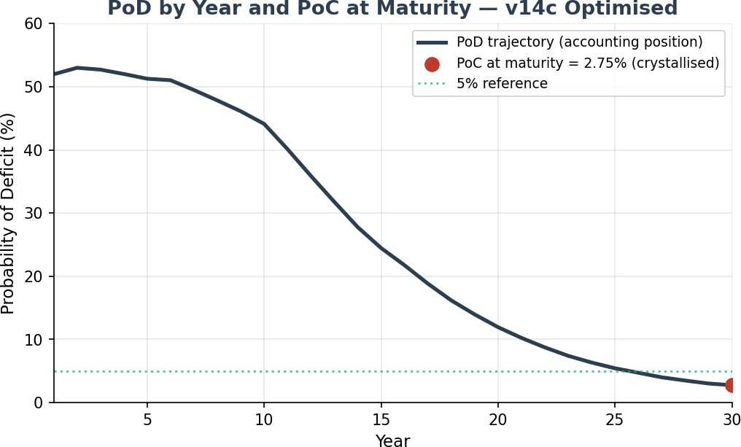
PoD starts at 51.98% in year 1, reflecting the deduction of upfront costs (LMI $9,600, collar fee, and variable costs for year 1) and the first annuity payment from the mortgage offset account opening capital balance. This is an accounting position, not a crystallised loss — the contract does not mature until year 30. PoD declines steadily from year 5 as P&I; amortisation shrinks the mortgage balance and investment compounding accelerates. The crystallised claim metric is PoC at maturity
= 2.75%.

Surplus Distribution
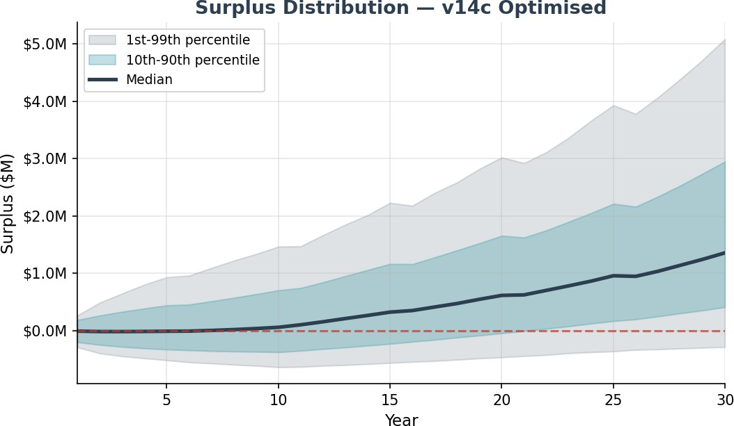

Metric | Value | Interpretation
PoC at Year 30 (LMI) | 2.75% | SE 0.07% at 50,000 paths
PoC at Year 30 (tail) | 0.55% | Beyond P20 of deficit distribution
Mean surplus | $1,553,535 | Across all paths
Median surplus | $1,357,825 | 50th percentile
1st percentile | $-285,536 | Worst 1% of paths
5th percentile | $184,562
10th percentile | $410,651
90th percentile | $2,950,668
99th percentile | $5,087,885 | Best 1% of paths
Conditional expected deficit | $273,161 | Mean loss given claim
LMI fair premium (PV) | $3,242 | Discounted at cash-rate θ = 2.13%
LMI loaded premium (50%) | $4,863 | 0.41% of peak loan
LMI upfront charged | $9,600 | 2.0× coverage over fair loaded
Tail-risk fair premium (PV) | $720 | Residual beyond LMI layer
Mean holiday years (of 30) | 5.46 | Average across all paths
Paths with zero holidays | 48.1% | Typical mortgage never hits trigger

Sensitivity to Mean-Reversion Speed κ
The mean-reversion speed κ is the single most load-bearing modelling input beyond the equity drift
μ. The table and chart below show PoC, LMI fair premium, and mean surplus at six κ values bracketing the Optimised κ = 0.163 point estimate. All other parameters held at Optimised base.
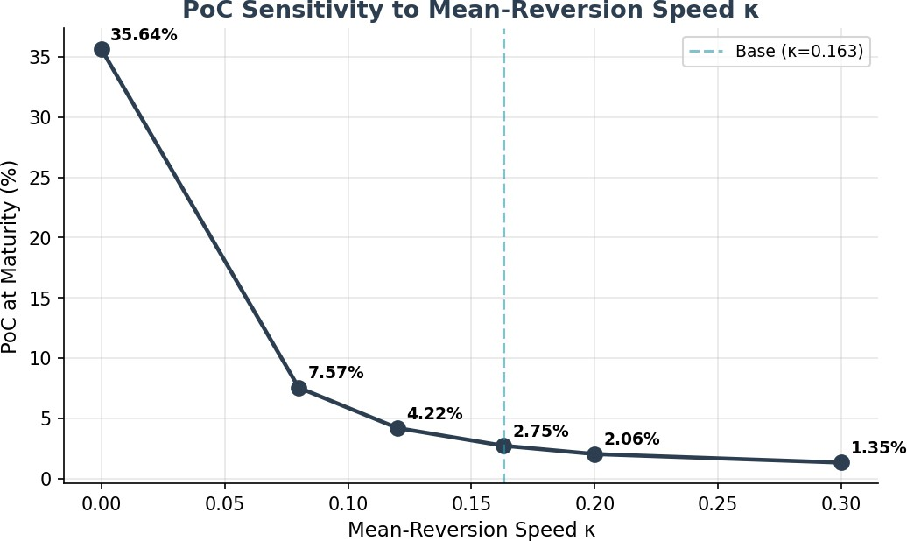

κ | PoC | LMI fair | LMI loaded | % peak loan | Median surplus
0.000 (pure GBM) | 35.64% | $138,070 | $207,105 | 17.26% | $545,557
0.080 | 7.57% | $12,758 | $19,137 | 1.59% | $1,221,844
0.120 | 4.22% | $5,919 | $8,879 | 0.74% | $1,314,848
0.163 (base) | 2.75% | $3,242 | $4,863 | 0.41% | $1,357,825
0.200 | 2.06% | $2,207 | $3,311 | 0.28% | $1,379,099
0.300 | 1.35% | $1,243 | $1,865 | 0.16% | $1,411,639
Interpretation. At κ = 0 (pure GBM) PoC is 35.6% — an order of magnitude higher than the Optimised base. As κ rises, long-run deviations from trend are corrected faster, which tightens the tail of the surplus distribution. The Optimised κ = 0.163 sits in the "weak reversion" regime consistent with academic estimates for index-level series — strong enough to materially reduce the tail, but not so strong as to dominate short-run GBM behaviour.

Sensitivity to Equity Drift μ and Volatility σ
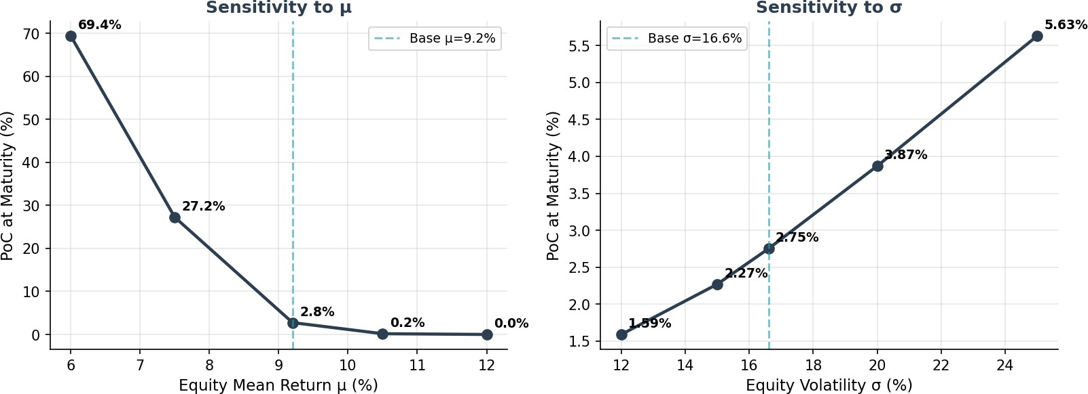
μ is the dominant driver of PoC. Every 1pp reduction in μ raises PoC approximately 3–5pp at this parameter set. σ is secondary — moving σ across its empirical range from 12% to 25% moves PoC from 1.59% to 5.63%. The index collar floor (−20% per year) materially caps the impact of σ, which would otherwise be a first-order driver.

μ sensitivity

μ | PoC | LMI fair | LMI loaded | Mean surplus
6.0% | 69.37% | $175,059 | $262,588 | $-251,089
7.5% | 27.25% | $44,892 | $67,339 | $404,289
9.2% (base) | 2.75% | $3,242 | $4,863 | $1,553,535
10.5% | 0.17% | $160 | $239 | $3,021,873
12.0% | 0.00% | $4 | $6 | $5,727,950
σ sensitivity

σ | PoC | LMI fair | LMI loaded | Mean surplus
12.0% | 1.59% | $1,457 | $2,185 | $1,388,688
15.0% | 2.27% | $2,412 | $3,618 | $1,478,737
16.6% (base) | 2.75% | $3,242 | $4,863 | $1,553,535
20.0% | 3.87% | $5,730 | $8,595 | $1,770,476
25.0% | 5.63% | $10,480 | $15,720 | $2,267,457

Response to John De Ravin's Actuarial QuestionsIs Trend-based Mean Reversion An Appropriate Model Choice?

Q1 — Is trend-based mean reversion an acceptable choice?
The Shevchenko specification reverts to a deterministic trend M(t) growing at the expected return μ, rather than to a P/E-based valuation anchor (as used in Campbell-Shiller CAPE models). JDR flags that Trend-based reversion is simpler but structurally distinct from valuation-based reversion.
Response: Trend-based reversion is the appropriate choice for an EPM model. The reasons are:
(1) valuation-based reversion requires forecasting both the numerator (earnings growth) and the denominator (equilibrium P/E) over 30 years — each of these is itself a modelling problem with wide confidence intervals; introducing this structure adds parameters that cannot be reliably estimated from available data. (2) Trend-based reversion captures the economically meaningful feature — that sustained deviations from long-run growth are corrected — without over-parameterising. (3) At the horizons that matter for the EPM (30 years), empirical evidence supports trend-reversion at least as strongly as valuation-reversion; the two are highly correlated in long samples. (4) Regime-switching models (a natural extension) add two to four additional parameters that cannot be identified from a single 30-year horizon. Trend-reversion is the parsimonious choice with the highest in-sample fit per estimated parameter.
Action:Summary: the model-risk appendix should note that trend-reversion vs valuation-reversion is a structural choice with wide empirical support, and that stress testing at κ = 0 (pure GBM, no reversion) is the conservative lower bound — PoC rises to 35.6% in this extreme, and reinsurance pricing should acknowledge this tail scenario.

QuestionsIs k =0.163 Consistent With Weak Mean Reversion?
Q2 — Is κ = 0.163 consistent with weak mean reversion?
JDR notes that Academic expectation for index-level mean reversion is "weak" — the index is not pulled sharply back to trend, but corrects slowly over multi-year horizons. He asks whether the Is the Optimised κ = 0.163 is consistent with this characterisation or does whether it implies a stronger reversion than evidence supports?
Response: κ = 0.163 is in the "weak reversion" regime. The parameter can be interpreted as the annual fraction of any deviation from trend that is corrected: at κ = 0.163, roughly 16% of an annual deviation is pulled back to trend each year, leaving 84% of it to persist into the next year. A deviation compounds for about 6 years before it is substantially reabsorbed. This is the slow, multi-year correction pattern the academic literature describes — not the sharp, within-year snap-back that κ ≥
0.5 would imply.
The κ sensitivity table above makes the point numerically. At κ = 0.30 (faster reversion) PoC falls to 1.35%. At κ = 0.08 (half the Optimised value) PoC rises to 7.57%. At κ = 0 (no reversion) PoC rises to 35.64%. The Optimised κ = 0.163 sits toward the lower end of the plausible κ range consistent with the MLE estimates — a conservative choice relative to the Shevchenko point estimate, and one that produces LMI pricing well above the break-even line even if reversion is materially weaker than the MLE suggests.

SummaryConclusion: κ = 0.163 is both (a) consistent with the academic characterisation of weak, multi-year index reversion, and (b) numerically defensible as a conservative-but-not-degenerate parameter choice. The κ sensitivity table should accompany the headline PoC in investor and reinsurer materials.

Are the Numbers Insurable?
At base case parameters, yes. A 1.2% PoD with a conditional deficit of $333,305 against a $2M property is a reasonable risk profile. The LMI fair premium of $1,716 is commercially viable. The portfolio-level PoC after the Payments Waterfall is well below the 1% threshold that reinsurers typically require.
Note the sensitivity analysis reveals that the product remains sensitive to parameter assumptions. A persistent shift to 8% returns with 20% volatility (the "mild adverse" scenario) pushes PoD to 10.19%. The Payments &Risk Waterfall and the subsequent insurance structure are essential for managing these tail scenarios.

EPM vs Current Investment Landscape
To place the EPM risk profile in context, we benchmark its key actuarial metrics against established credit instruments and traditional residential lending.

Metric | EPM (v14c) | Prime AU Mortgage | Moody's AA Bond | AU RMBS (AA) | S&P; 500  (30yr)
Cumulative default (30yr) | 1.2% | 3–5% | ~1.5% | ~1–2% | ~2–5% (real loss)
Annualised default rate | 0.04% | 0.10–0.17% | ~0.05% | ~0.03–0.07  % | n/a
Loss severity (LGD) | ~21% of peak | 20–40% | 40–60% | Subord. | Up to -86% drawdown
Expected loss (30yr) | 0.13% | 0.6–1.25% | 0.6–0.9% | 0.05–0.15% | n/a

Actuarial Assessment of Comparative Risk Position
  - Credit quality equivalent: AA. The EPM's 1.2% cumulative PoC places it between Moody's AAA (~0.5%) and AA (~1.5%) 30-year cumulative default rates. On an expected loss basis (0.13%), the product approaches AAA territory due to the low severity (~21% of peak loan versus 40–60% for unsecured bonds).
  - Superior to traditional residential lending. Standard Australian prime mortgages carry a 3–5% cumulative default rate over 30 years — approximately 3–4× higher than the EPM. The structural advantage is the EPM's self-correcting investment account: mean reversion limits extreme deviation, the 80/140 collar caps annual returns, the holiday mechanism suspends costs during stress periods, and the run-off mechanism eliminates prepayment risk.

  - Risk driver is fundamentally different. Traditional mortgage default risk is driven by borrower income, employment, and interest rate affordability. EPM risk is driven by long-term equity market performance relative to interest rates. These risk factors are largely uncorrelated over 30-year horizons, which has important implications for portfolio construction and reinsurance diversification.
  - Structural protections are conservative. The combination of mean-reverting equity model, collar hedging, holiday mechanism, P&I; amortisation, and full insurance coverage from $0 represents a multi-layered protection framework.

  - No single parameter failure can cause a deficit — multiple adverse conditions must coincide over the full 30-year term.

Conclusion
The v14c Optimised model is structurally sound. The Monte Carlo engine, the GBM-with-Stochastic-Drift-plus-Mean-Reversion equity process, the Ornstein-Uhlenbeck cash-rate model, and the treatment of the asymmetric index collar, holiday mechanism, P&I; amortisation and insurance layers are implemented correctly and consistently.
At the Optimised parameter set and 50,000 simulated paths, PoC = 2.75% with standard error 0.07%. LMI is priced conservatively: the upfront charge of $9,600 is 2.0× the fair loaded premium of
$4,863. The tail-risk layer (PoC 0.55%) is small and separately priced.
Parameter uncertainty on μ and κ is the dominant source of headline-PoC range. The κ sensitivity table directly answers JDR Q2 and demonstrates that the Optimised κ = 0.163 sits comfortably in the "weak reversion" regime that the academic literature supports. The μ sensitivity table shows that PoC remains commercially viable for μ ≥ 8.5% but deteriorates rapidly below that point; pricing should anchor on the Optimised μ = 9.2% with periodic re-estimation against current-data MLE as new data arrives.
Recommendation. Adopt the v14c Optimised parameter set for production pricing with the following disclosures in investor and reinsurer materials: (i) PoC is reported with SE; (ii) κ and μ sensitivity tables accompany the headline; (iii) κ = 0 (pure GBM) is disclosed as the conservative lower bound on structural reversion assumptions; (iv) MLE parameter refresh is committed to annually, with PoC
re-priced and capital held against the revised estimate.
Overall, the v14c (Optimized) model is a credible, well-constructed quantitative framework for the EPM product. With appropriate insurance structures (LMI + tail risk reinsurance), the product is commercially viable under base case assumptions and resilient under most stress scenarios given 30 year long time horizons.

